**FSSI PRACTICLE EXAM**

**Name:-** Aryan Dilipbhai Langhanoja

**Enrollment No**:- 92200133030

**QUESTION-1:-**

LINK:- <https://www.tinkercad.com/things/l0xyK8WfDFq-brilliant-crift/editel?tenant=circuits>

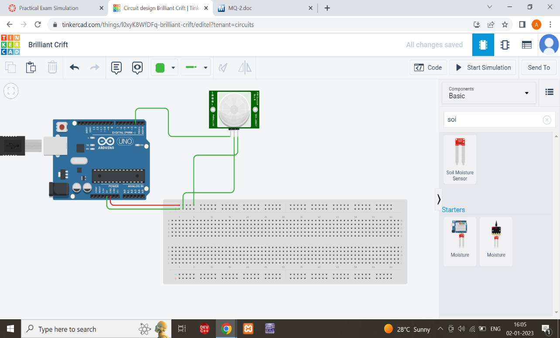

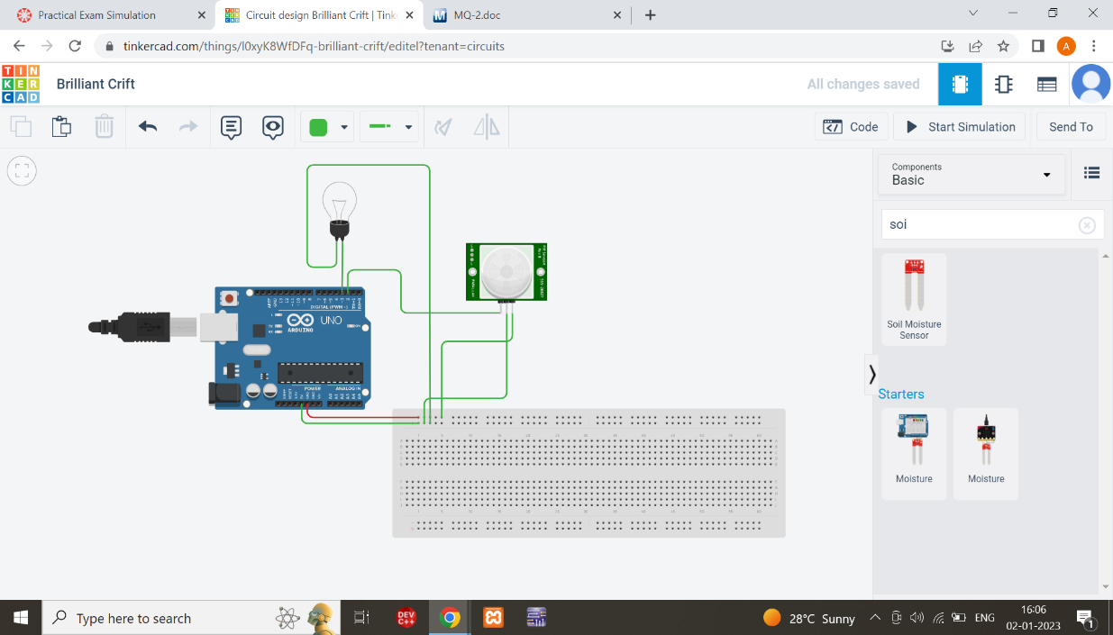

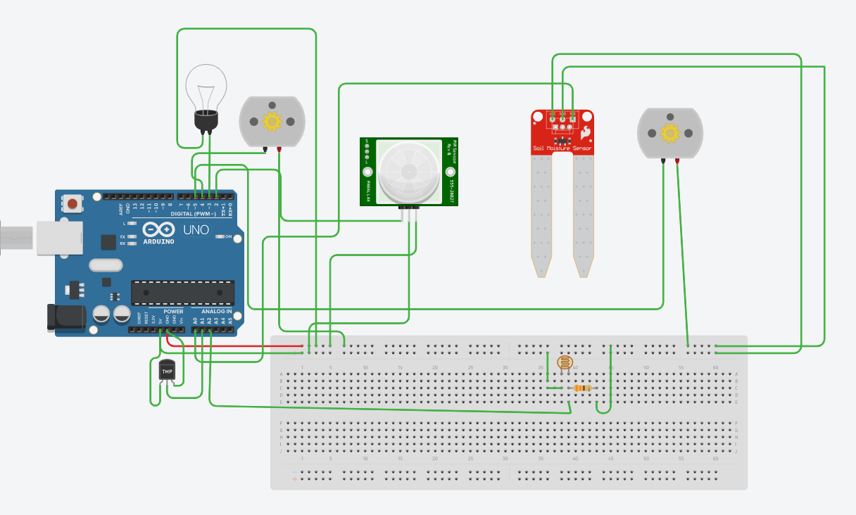

**CODE:-**

// C++ code

//

void setup()

{

pinMode(2, INPUT);

pinMode(A0,INPUT);

pinMode(A1, INPUT);

pinMode(3 , OUTPUT);

pinMode(4, OUTPUT);

pinMode(5, OUTPUT);

pinMode(A2,INPUT);

}

void loop()

{

double motion,soil,temperature,ldr;

motion=digitalRead(2);

soil=analogRead(A0);

temperature=analogRead(A1);

ldr=analogRead(A2);

Serial.print(temperature);

Serial.print("\n");

if(motion==1 && ldr<=200)

{

digitalWrite(3 ,HIGH);

}

else

{

digitalWrite(3 ,LOW);

}

if(motion==1 && temperature>=150)

{

digitalWrite(4 ,HIGH);

}

else

{

digitalWrite(4 ,LOW);

}

if(soil<=400)

{

digitalWrite(5 , HIGH);

}

else

{

digitalWrite(5 , LOW);

}

}

**QUESTION-3**

**LINK:-** [**https://www.tinkercad.com/things/kxk5O2E2kw5-brilliant-bruticus/editel?tenant=circuits**](https://www.tinkercad.com/things/kxk5O2E2kw5-brilliant-bruticus/editel?tenant=circuits)

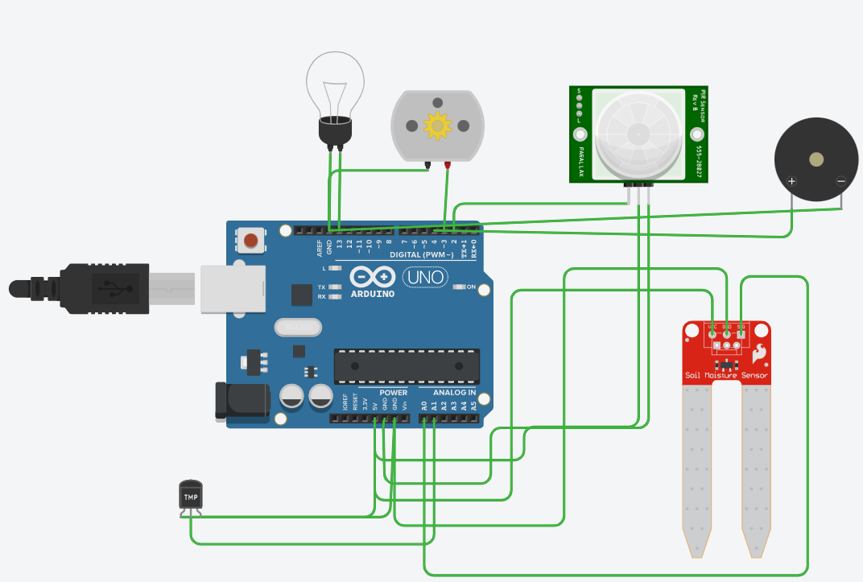

CODE:-

// C++ code

//

void setup()

{

pinMode(13, OUTPUT);

pinMode(3 , OUTPUT);

pinMode(2 , INPUT);

pinMode(4 , OUTPUT);

pinMode(A1 , OUTPUT);

}

void loop()

{

double motion,soil,temp;

motion= digitalRead(2);

soil=analogRead(A0);

temp=analogRead(A1);

if(motion==1)

{

digitalWrite(13,HIGH);

digitalWrite(4,HIGH);

}

else

{

digitalWrite(13,LOW);

digitalWrite(4,HIGH);

}

if(soil<=400)

{

digitalWrite(3,HIGH);

}

}